C:\Users\SchlarbS\Desktop\DAS-Board-06.jpg

**Archival Information Package (AIP)**

**E-ARK AIP version 1.0**

**January 27th 2017**

**Executive Summary**

This *E-ARK* AIP format specification defines the requirements for building Archival Information Packages (AIPs) containing the information to be stored by an archive for the long term. This format specification is based on the E-ARK AIP format specification developed in E-ARK project, namely deliverable, D4.4 “Final version of SIP-AIP conversion component”.[1] It relates to part A of this deliverable which is the AIP format specification. A reference implementation of this specification is also described in this deliverable as part B which documents the implementation of the SIP-AIP conversion component implemented in the integrated platform[2] as part of the *earkweb* component.[3]

**TABLE OF CONTENTS**

1 Scope of this document 5

2 Relation to other documents 5

3 Introduction 6

4 Preliminary definitions and remarks 7

4.1 Representations 7

4.2 Logical and physical representation of the AIP 8

4.3 Structural division of the AIP 8

4.4 Authenticity of the original submission 9

4.5 Version of an AIP 9

4.6 Cardinality of the SIP to AIP transformation 10

5 AIP format specification 11

5.1 Common Specification for Information Packages 11

5.1.1 Common Specification for IPs structure 11

5.2 E-ARK AIP structure 16

5.2.1 AIP container for submissions 16

5.2.2 AIP representations 19

5.2.3 Changing the metadata of the original submission 21

5.2.4 Parent-Child relationship 22

5.2.5 Representation Information in the E-ARK AIP 23

5.3 E-ARK AIP metadata 26

5.3.1 Structural metadata 26

5.3.2 Preservation metadata 33

E-ARK AIP Physical Container Package 43

5.3.3 Package manifest 43

6 Appendices 45

6.1 Appendix A - METS.xml referencing representation METS.xml files 45

6.2 Appendix B – METS.xml describing a representation 46

6.3 Appendix C - PREMIS.xml describing events on package level 48

6.4 Appendix D - PREMIS.xml describing migration events (representation level) 48

**List of Figures**

Figure 2: General E-ARK IP structure 13

Figure 3: Minimum E-ARK IP structure requirements 14

Figure 4: One METS.xml file in the root of the IP references all metadata and data files 15

Figure 5: Root METS.xml file references METS files of the different representations 16

Figure 6 Example of an E-ARK IP 17

Figure 7: The AIP's "submission" folder contains the IP of the original submission 20

Figure 8: The AIP contains submissions in subfolders to support submission updates 20

Figure 9: AIP representations 21

Figure 10: AIP representations 21

Figure 11: AIP using representation-based division of METS.xml files 22

Figure 12: METS.xml files in the AIP’s “Metadata/submission” directory have priority over the ones contained in the original submission 23

Figure 13: Parent-child relationship between AIPs 24

Figure 15: New version of a parent-AIP 24

**List of Tables**

Table 1: New version of a parent-AIP 28

Table 2: Attributes of the file element 29

Code Listings

Listing 1: METS root element example with namespace and namespace location definitions 29

Listing 2: Example of a file in the fileSec as child of a fileGroup element (long attribute values replaced by “...” for better readability) 29

Listing 3: Compressed file 31

Listing 4: Linking to an EAD XML descriptive metadata file 31

Listing 5: Linking to an EAD XML descriptive metadata file 32

Listing 7: Obligatory Common Specification structural map 32

Listing 6: Structural map referencing METS.xml files of the different representations 33

Listing 8: Using a structMap to reference the parent AIP 34

Listing 9: Using a structMap to reference the parent AIP 34

Listing 10: Object identifier 38

Listing 11: Hashsum (value shortened) 38

Listing 12: Optionally, the format version can be provided using the formatDesignation element. 39

Listing 13: JHove digital object characterisation 39

Listing 14: Original name 39

Listing 15: Storage description 40

Listing 16: Relationship 40

Listing 17: Rights statement 41

Listing 18: Event identifier 41

Listing 19: Event date/time 41

Listing 20: Link to agent/object 42

Listing 21: Migration event 43

Listing 22: Software as an agent 43

Listing 23: Discovery right statement 44

Listing 24: Manifest file 45

# Scope of this document

The current document constitutes a specification of the E-ARK Archival Information Package (AIP) format specification. It is important to note that there is a common structure shared between the different types of information packages which is defined by a document called “Common Specification for Information Packages”.[4] The current document references this Common Specification and focuses on the structural peculiarities of the AIP format and the implementation as part of the reference implementation E-ARK Web (in short: *earkweb*).[5]

, there are.T

# Relation to other documents

This *DAS Board* AIP format specification is an adapted and improved version of the format specification for Archival Information Packages (AIPs) developed in E-ARK project, namely deliverable, D4.4 “Final version of SIP-AIP conversion component”.[6]

More concretely, it relates to part A of this deliverable which is the AIP format specification. A reference implementation of this specification is also described in this deliverable as part B which documents the implementation of the SIP-AIP conversion component implemented in the integrated platform[7] as part of the *earkweb* component.[8]

As already mentioned in section 1, the current document relates to the “Common Specification for Information Packages”.

The fundamental document to understand the purpose of the AIP format is the Reference Model for an Open Archival Information System (OAIS).[9]

# Introduction

The E-ARK AIP format specification defines a basic structure for how to store submitted information packages (SIPs[10]) and also how to store changes over time due to metadata edits, digital preservation strategies (e.g. migration or adding emulation information), or submission updates.[11] Compliance with the AIP format defined by this specification means that an AIP makes this structure explicit and that the structural components can be identified correctly.

The purpose of defining a standard format for the archival information package is to pave the way for simplified repository migration. Given the increasing amount of digital content archives need to saveguard nowadays, changing the repository solution should be based on a standard exchange format. This is to say that a data repository solution provider does not necessarily have to implement this E-ARK AIP format as the internal storage format, but it should at least allow exporting E-ARK AIPs. By this way, the costly procedure of exporting data, producing SIPs, and ingesting them again in the new repository can be simplified. Data repository solution providers know what kind of existing data they can expect if they were chosen to replace an existing repository solution. A E-ARK compliant repository solution should be able to immediately analyse and incorporate existing data in form of E-ARK AIPs without the need of applying data transformation or having to fulfil varying SIP creation requirements.

Repository systems are not expected to implement this AIP format, however, they are expected to be able to generate it it in a simple way for a set of AIPs.

On the one hand, the AIP format specification consists of an obligatory set of structural requirements which will be explained more precisely in section 5. At this point, it is important to note that the structure of the AIP could be, in principle, expressed in terms of structural metadata only (e.g. by use of an E-ARK specific *structMap* in a METS document). However, the E-ARK implementations, which make use of AIPs, require the structure of the AIP to be implemented as a file system folder hierarchy to make it clear for both humans and tools where to find what[12]. This means that the implementation of the structure of the AIP format as described in section 5 is a necessary condition to make use of the E-ARK reference implementation of *earkweb*.

On the other hand, the compliance rules regarding implementation of structural and preservation metadata are defined by the Common Specification. Section 5 of the AIP format specification contains the documentation of the implementation of structural and preservation metadata in the E-ARK reference implementation of *earkweb*.[13]

# Preliminary definitions and remarks

## Representations

The concept of “representation” is crucial in the context of E-ARK and it is generally used according to the definition given in the context of the PREMIS digital preservation metadata standard[14]:

"The set of files, including structural metadata, needed for a complete and reasonable rendition of an Intellectual Entity. For example, a journal article may be complete in one PDF file; this single file constitutes the representation. Another journal article may consist of one SGML file and two image files; these three files constitute the representation. A third article may be represented by one TIFF image for each of 12 pages plus an XML file of structural metadata showing the order of the pages; these 13 files constitute the representation."[15]

Representations are a core concept of the E-ARK Information Package (IP) according to the Common Specification. The peculiarity in the context of the AIP is that, on the one hand, representations are included in the SIP and need to be stored as part of the submission, and, on the other hand, representations can be created during SIP to AIP conversions or as a result of repository maintenance operations.

It should also be mentioned thatrepresentations can be derived from each other; this is typically the case if digital objects making up a representation that are migrated to another format, being the derived representation the set of digital objects in the new format. However, a new representation can be not only the result of a file format migration, but can also the set of instructions presented as part of representation metadata on how to create an emulation environment in order to render a set of files.

## Logical and physical representation of the AIP

In line with OAIS, we call the logical container of the AIP the complete set of digital objects and metadata representing the conceptual entity as a whole. The conceptual entity must be distinguished from the physical representation of one or possibly more physical containers which represent one conceptual entity.

From the point of view of preserving the integrity of the AIP, the ideal case is that the logical AIP representing the intellectual entity is packaged as one single physical container. This way recovery is much easier because the physical container has all the information required to interpret and render the contained representations. In reality, however, this is not always possible because the size of the physical container can become very large, and this is the reason for proposing the divided METS structure described in section 5.1.1.2. The divided structure makes it easier to manage representations or representation parts separately. In both cases, the representation-based and the size-based splitting described in section 5.1.1.3, the purpose is to store each of the constituent parts as one physical container.

## Structural division of the AIP

One of the basic requirements prescribed by the Common Specification is to use *METS[16]* as the metadata standard to describe the structure of the AIP – in line with the decision related to the other package types, namely the SIP and the DIP.

E-ARK paid special attention to the situation that it might not be possible to store all representations of an intellectual entity in one physical container, or that even a single representation might have to be divided so that it can be stored on long-term storage media. In order to make it easier to manage representations or representation parts separately E-ARK proposes a “divided” METS structure using a *METS.xml* file in the root directory of the AIP which references *METS.xml* files of the individual representations. This structure lays the groundwork for addressing the practical requirement of distributing parts of the intellectual entity over a sequence of physical containers representing a logical AIP. Even though this puts the integrity of the AIP at risk - because in case of disaster recovery the physical container does not represent the complete intellectual entity and dependencies to another (lost) physical container can potentially make it impossible to interpret, understand, or render the content - it is a necessary measure if the amount of data exceeds the capacity limitation of long-term storage media.

On the other hand, there might be the need to put a constraint on the size of the physical containers of the AIPs to allow storing them on long-term storage media more easily. In this case, E-ARK proposes a “compound” structure using a single *METS.xml* file that contains all references to the data and metadata of the package.

## Authenticity of the original submission

The AIP format provides a structure for storing the original submission separately from any data that is created during SIP to AIP conversion and during the life-cycle of the AIP. This allows safeguarding the authenticity of the original submission.

However, it is an implementation decision if the original submission is kept “as is” or if the SIP data is adapted during SIP to AIP conversion. In line with OAIS, the content of the original SIP does not have to be identical to the version of the submitted data stored as part of the AIP:

“An OAIS is not always required to retain the information submitted to it in precisely the same format as in the SIP. Indeed, preserving the original information exactly as submitted may not be desirable.”[17]

The E-ARK AIP format prescribes a structure by defining a set of requirements and core metadata together with recommendations on how to use the requirements in order to allow changing the AIP while keeping seamless track of the AIP’s history.

## Version of an AIP

While the AIP always describes the same unaltered conceptual entity, the way in which this information is represented may change. Therefore the E-ARK AIP format describes the means to record the provenance from the time of the first submission, and also during the life-cycle of the AIP.

For the purpose of the AIP format specification, the “AIP version” concept used in E-ARK is as defined by OAIS:

“AIP Version: An AIP whose Content Information or Preservation Description Information has undergone a Transformation on a source AIP and is a candidate to replace the source AIP. An AIP version is considered to be the result of a Digital Migration.”[18]

A new version of an AIP contains one or more new representations which according to the E-ARK understanding can be either the result of a digital migration or information that enables the creation of an emulation environment to render a representation. The result of this operation is the creation of a new version of the AIP.

The result of a new version of the AIP is stored separately from the submission as explained in detail in section 5.2.2.

Furthermore, the E-ARK AIP format allows updating the AIP by adding a new version of the submission. This allows supporting the AIP edition which is defined in OAIS as follows:

“AIP Edition: An AIP whose Content Information or Preservation Description Information has been upgraded or improved with the intent not to preserve information, but to increase or improve it. An AIP edition is not considered to be the result of a Migration.”[19]

The result of an AIP Edition is stored as part of the submission as explained in detail in section 5.2.1.

## Cardinality of the SIP to AIP transformation

While “within the OAIS one or more SIPs are transformed into one or more Archival Information Packages (AIPs) for preservation”[20], the *earkweb* reference implementation only supports converting one single SIP into one single AIP. Note that according to the Common Specification there is no restriction regarding the cardinality of SIP to AIP transformations.

Also in the special case that one intellectual entity is divided into a series of SIPs, the SIP to AIP conversion is by definition a one-to-one mapping. However, the AIP format allows defining that these AIPs belong together so that it is possible to aggregate the parts in order to reconstruct the intellectual entity.

# AIP format specification

The purpose of the AIP format is to provide a logical and physical container for E-ARK Information Packages (IP)[21] which is adequate for preserving digital objects over a long time period while keeping track of any changes by recording the provenance of the IP.

The E-ARK AIP format will be explained with the help of textual descriptions, figures, and examples. The actual AIP format specification is defined as a set of requirements[22].

The AIP format specification is divided into two parts. On the one hand, there is the structure and metadata specification which defines how the AIP is conceptually organized by means of a directory hierarchy in a file system and a set of metadata standards. And on the other hand, there is the physical container specification which defines the bit-level manifestation of the transferable entity. Both parts of the specification can be regarded as independent from each other which means that either can be used with another counterpart.

Before dealing with the actual AIP format we will describe the E-ARK IP (i.e. an information package which complies with the Common Specification) structure because the AIP format is basically a container which allows managing the life-cycle of an E-ARK IP starting with the ingest of an SIP.

## Common Specification for Information Packages

In this section we briefly describe the structure of IPs which comply with the Common Specification for Information Packages (Common Specification for IPs) – defined by a set of rules applicable for the information package types SIP, AIP, and DIP – with a focus on the parts that are relevant for the AIP.

### Common Specification for IPs structure

As already mentioned in section 2.1, the Common Specification for IP format relies on the concept of “representations”. Given an example of two distinguishable representations, Figure 1 shows the general structure of an Common Specification for IPs according to which the metadata (folder “metadata”) and the data (folder “data”) are strictly separated. It also shows that in this example the two data folders are separated into two different branches. These two branches separate different “representations” of the same intellectual entity.

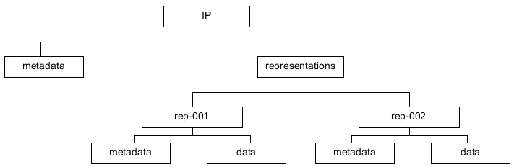

Figure 1: Structure of an IP compliant with the Common Specification for IPs

Furthermore, Figure 1 shows that metadata can be stored either at the representation level or at the IP level. In section 5.2 it will be explained in more detail where different types of metadata can be stored. For now, it is sufficient to mention that descriptive, technical, preservation, and rights metadata can relate either to the IP as a whole or to individual representations.

Based on these assumptions, the following requirements for the general IP structure need to be taken into account in the context of the AIP format:

1. An IP MUST contain a “representations” directory.
2. Representations MUST be stored in distinct subdirectories of the “representations” directory. The names of these subdirectories can be chosen freely.
3. An IP MUST contain a “metadata” directory.
4. The “Metadata” directory SHOULD be divided into “descriptive”, “preservation”, and “other” subdirectories for storing the corresponding category of metadata.
5. The root directory of the package MUST contain a METS.xml file which is created according to the rules defined in section 5.3.1.

Following these requirements, the minimal obligatory structure of an IP compliant with the Common Specification for IPs is essentially as shown in Figure 2.[23]

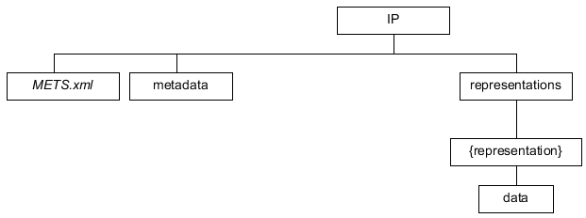

Figure 2: Requirements regarding the structure of IPs compliant with the Common Specification for IPs

The use of other components of the IP format depends on institutional preferences related to the use of structural metadata, and generally the type and amount of content that needs to be archived using this structure.

In the following section we will use a concrete example to describe the two alternatives of using either a compound or a divided METS structure in more detail.

Let us assume that we have an IP with two representations, each of which consists of a set of three files. In the first representation all data files are in the Open Document Format (ODT) and in the second one - as a derivative of the first representation - all files are in the Portable Document Format (PDF).

#### Compound METS structure

The first option, as shown in Figure 3, is to have a single *METS.xml*[24] file that contains all references to metadata and data files available of the IP which is called “compound” or “simple” METS structure.

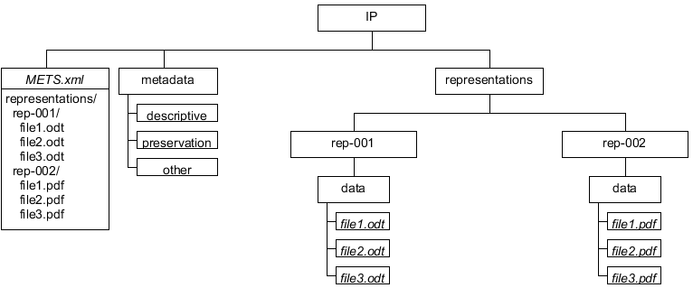

Figure 3: One METS.xml file in the root of the IP references all metadata and data files

Even though the number suffix of the directories “rep-001” and “rep-002” of the example shown in Figure 3 suggests an order of representations, there are no requirements regarding the naming of directories containing the representations. The order of representations and the relations between them is defined by the structural and preservation metadata. The “representations” directory is mandatory, even for IPs which contain only one representation (Requirement 1).

#### Divided METS structure

The second option, called “divided” METS structure, as shown in Figure 4, is to have separate *METS.xml* files for each representation and the *METS.xml* in the IP’s root directory points to the *METS.xml* files for each of the representations. More concretely, the example shown in Figure 4 has a *METS.xml* file in the IP’s root which points to the *METS.xml* files “Representations/Rep-001/METS.xml” and “Representations/Rep-002/METS.xml”. Sections 5.3.1.6 and 5.3.1.7 provide more details about how the referencing of *METS.xml* files must be implemented if this alternative is chosen.

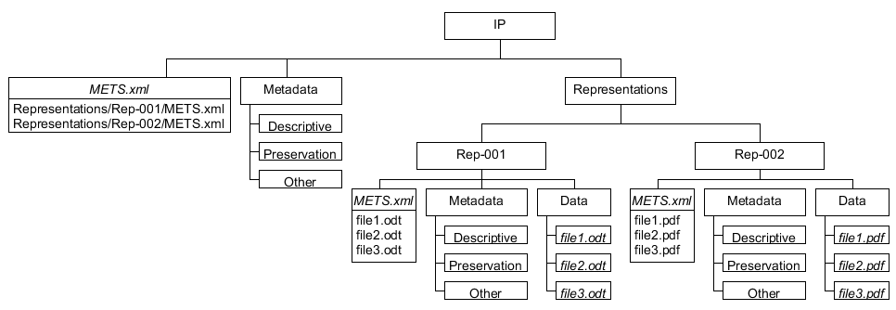

Figure 4: Root METS.xml file references METS files of the different representations

The reason why this alternative was introduced is that it makes it easier to manage representations independently from each other. This can be desired for very large representations, in terms of file size (e.g. a binary database and the database in a vendor independent XML format as two separate representations) or the amount of files (making the root METS difficult to work with).

#### Representation-based vs. size-based division

As a corollary of this division method we define, on the one hand, a *representation-based division* as the separation of representations in different directories under the “representations” folder as shown in the example of Figure 4. And, on the other hand, we define a *size-based division* as the separation of representation parts. To illustrate this, Figure 5 shows an example where a set of files belongs to the same representation (here named “binary”) and is referenced in two separate physical containers (here named {C1} and {C2} respectively). A key requirement when using size-based division of a representation is that there must not be any overlap in the structure of the representations, and that each sub-directory path must be unique across the containers where the representation parts together constitute a representation entity. Note that for this reason a numerical suffix is added to the representation METS.xml files, to avoid overwriting representation METS.xml files when automatically merging the divided representation back into one single physical representation.

1. If a representation is divided into parts, the representation component MUST use the same name in the different containers.
2. If a representation is divided into parts, there MUST not be any overlap in the structure of the representations and each sub-directory path MUST be unique across the containers

It must be noted that this size-based division method assumes that the separation into parts is based on criteria determined by the archivist.

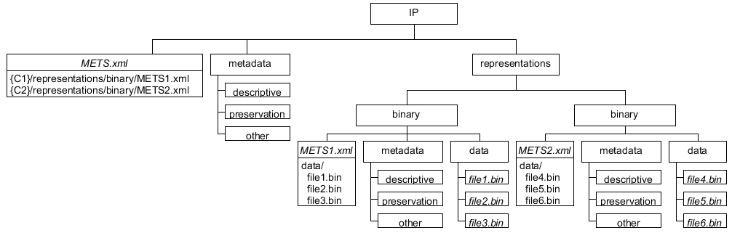

Figure 5 Example of an IP compliant with the Common Specification for IPs

#### Requirements

There is the basic requirement that the root of an IP contains a *METS.xml* file, but it can be freely chosen if this *METS.xml* file is broken down into *METS.xml* parts for the different representations.

1. The root of the package MUST contain a METS.xml file that either references metadata and data files or references other METS.xml files located in the corresponding representation folders under the “representations” directory.

As already stated, only the “data” directory is obligatory for each representation. Additionally, there can be other directories at the representation level which are specified by the following requirements:

1. Each representation MUST contain a “data” directory. The structure within this directory can be freely chosen.
2. A representation COULD contain a “metadata” directory.
3. If a representation directory contains a “metadata” directory, it SHOULD be divided into “descriptive”, “preservation”, and “other” subdirectories for storing the corresponding category of metadata.
4. The representation directory COULD contain a “documentation” directory to store additional documents that explain the content available in the “data” directory.
5. The representation directory COULD contain a “schemas” directory to store additional XML Schema files that are needed to validate XML documents contained in a representation.

## E-ARK AIP structure

Based on the Common Specification for IPs described in the previous section, the AIP format specifies a logical structure and guidelines for using METS and PREMIS metadata to create E-ARK AIPs.

The AIP format offers a structure for storing the complete SIP, and it allows holding data and metadata which are created during SIP to AIP conversion and data that are created during the lifecycle of the AIP.

It is important to note that the AIP format implements the Common Specification for E-ARK information packages differently compared to the SIP and the DIP. The SIP and the DIP represent “snapshots in time”, one capturing the state of an information package at submission time (SIP), the other one capturing a specific form of delivery at the point in time when the information package for access was created (DIP). The AIP, in contrast, allows holding the original submission (snapshot of the IP at submission time), the outcome of preservation actions in the course of the life-cycle separately, and submission updates that occur after the AIP was created.

The main difference is that the AIP is an information package which can contain one or several E-ARK compliant IPs, namely SIPs. The purpose of this meta-structure is to allow applying changes to the AIP over time. This requires a specific structure which is not required in the SIP and the DIP. The AIP must therefore not be understood as an "extension" of the IP (as defined by the Common Specification) in the sense that it inherits general properties from the Common Specification for IPs which are complemented by AIP specific properties. This is the reason why the inherent structure of the AIP is different to the one of the SIP and the DIP.

### AIP container for submissions

The AIP format allows storing submissions; having the submission in its original form can help to ensure authenticity of its representations. For this purpose, the AIP format defines a “submission” folder in the root of the AIP which contains the original submission as well as any submission updates added after the AIP was created. The following obligatory requirement applies:

1. The root directory of the package COULD contain a “submission” folder which is container of the original submission and of any updates of SIPs which are submitted after the AIP was created.

The submission folder is a container for submissions. It can contain the original submission, i.e. an information package which must be compliant with the Common Specification for IPs. Or, in case updating submissions is allowed after the AIP was created, the submission folder can contain sub-folders which represent a series of original submission and submission updates.

If the submission folder does not contain a METS.xml file, it is assumed that one or several submissions are contained in subfolders.

1. The “submission” folder MUST contain the submitted IP directly or one or several IPs compliant with the Common Specification for IPs in sub-folders.

This means that any sub-folders must contain IPs.

1. If the “submission” folder contains one or several sub-folders, the sub-folders MUST contain IPs.

The naming scheme of these sub-folders can be freely defined. However, it should reflect the order of original submission and updates. This means that the folder names should allow alphanumerical ordering, for example, by using zerofill-number suffixes or by deriving the folder name from an ISO 8601 date.

1. Instead of an IP, the “submission” folder COULD contain one or several sub-folders where each of the sub- folders contains an IP (a submission). It is not allowed in this case that the submission folder contains a METS.xml file. The sub-folders containing IPs SHOULD allow alphanumeric sorting, e.g. by using zero-fill numbers or ISO 8601 date derived strings as part of the folder name.

Examples for submission folder names which allow alphanumerical sorting:

* Zero-fill number suffixes:
  + Submission-00001
  + Submission-00002
  + Submission-00003
  + …
* Date/time based strings:
  + 2017-12-25_ 081012
  + 2017-12-26_ 083401
  + 2017-12-27_ 090118
  + …
* Date string suffixes:
  + Submission-2017-12-25
  + Submission-2017-12-26
  + Submission-2017-12-27
  + …

Figure 6 shows the variant where the “submission” folder contains an IP which represents the original submission. Although this structure does not reflect the version of the submission, the versioning layer can be introduced when the AIP is updated. The IP contained in the submission folder must be moved to a version folder in that case.

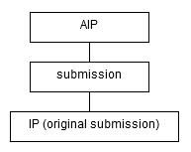

Figure 6: The AIP's "submission" folder contains the IP of the original submission

Figure 7 shows an example of the alternative structure, where the submission folder contains three sub-folders representing one original submission and two updates which were created over the course of three days.

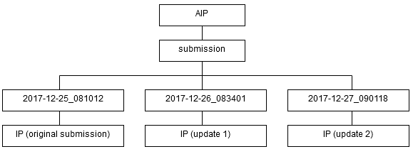

Figure 7: The AIP contains submissions in subfolders to support submission updates

For the sake of simplicity, only the first variant, i.e. where the “submission” folder directly contains an IP, is present in the following sections about the AIP structure.

### AIP representations

As described in section 5.1 in relation to an IP, one or several representations can be part of an SIP which is submitted to the repository. Additionally, the AIP must be able to include further representations which are either added during SIP to AIP conversion, or through measures which were taken as part of the repository maintenance or for digital preservation.

To illustrate this with the help of an example, Figure 8 shows the structure of an AIP where the original submission consists of two representations which were part of the original submission. The “submission” directory of the AIP contains the original submission “as is”, which means that neither data nor metadata is changed.

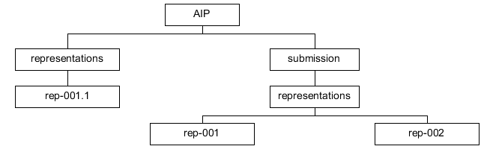

Figure 8: AIP representations

Let us now assume that during SIP to AIP conversion an additional representation is added to the AIP. Figure 9 illustrates an example where an additional “representations” directory exists as a sibling of the “submission” directory which contains a new representation (rep-001.1) derived from one of the representations contained in the original submission (rep-001).

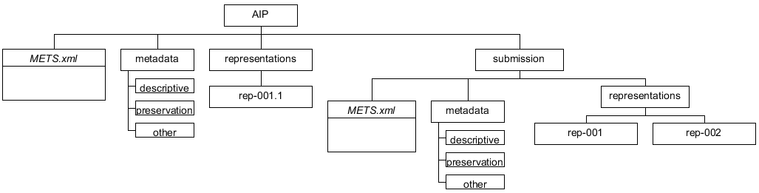

Figure 9: AIP representations

This leads to the following requirement regarding representations which are added during SIP to AIP conversion.

1. If a new representation is added during ingest (SIP to AIP conversion) or created as an AIP preservation measure (AIP to AIP conversion), the root directory of the AIP MUST contain a “representations” directory. For this directory, the same requirements as for the representations of an IP apply, namely requirements 9 to 13.

Note that the three-digit number suffix following the name “rep-” used in the example of Figure 9 indicates the order in time in which the representation of the original submission was created. And the additional number suffix after the dot indicates that the representation is a derivative of the representation identified by the three-digit number before the dot, i.e. “rep-001.1” is the first derivative of representation “rep-001”. This is however for illustration purposes only; the naming of representations does not have to follow such logic.

The AIP is an extension of the IP format; therefore it must follow the basic structure of an IP. Figure 9 shows that the IP components, consisting of *METS.xml* file, “Metadata” and “representations” directories, are repeated on the AIP level. The extension of the AIP format is basically given by the fact that the AIP is an IP which can contain another IP (i.e. a SIP) in the “submission” directory.

Note that the “representations” directory in the AIP root directory is optional. It means that this directory must only exist in case representations other than the ones originally submitted are added to the AIP.

1. The AIP is an IP, therefore requirement 8 applies and the AIP root MUST contain a METS.xml file that either references all metadata and data files or it references other METS.xml files located in the corresponding representation directories of the AIPs or of the original submission’s “representations”.

As a concrete example let us assume a policy stating that PDF documents must generally be converted to PDF/A.[25] Taking the premise formulated in section 4.4 into account that the original submission is not to be changed, the additional representation is added in a “Representation” directory in the root of the AIP as shown in figure 7. Note that this example uses a representation-based division of *METS.xml* files.

Analogously to Figure 8 there are also two representations in the original submission shown in Figure 10. The first representation (“Rep-001”) consists of a set of files in the Open Document Format (ODT) and the second one (“Rep-002”) is a derivative of the first set of files in the Portable Document Format (PDF). As an example we assume that an institutional policy prescribes that every PDF document must be converted to PDF/A during SIP to AIP conversion. Therefore the second representation (“Rep-002”) was converted to a set of PDF/A files and added to the AIP as an additional representation (“Rep-002.1”).

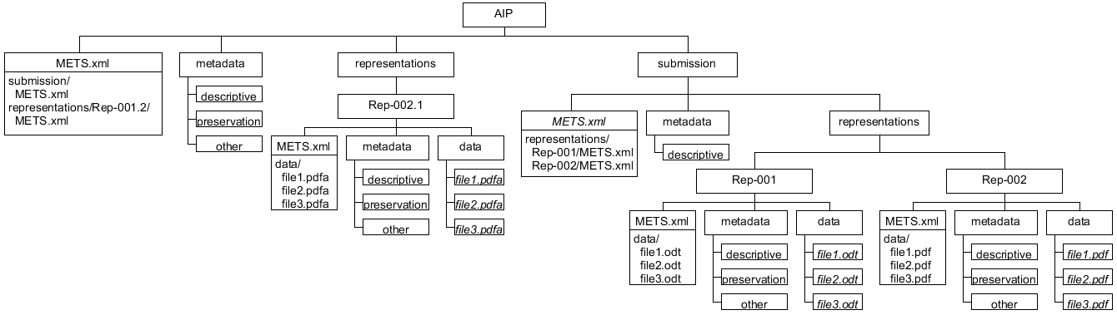

Figure 10: AIP using representation-based division of METS.xml files

The two representations of the original submission are located in the “submission/representations” directory of the AIP and the *METS.xml* file of the submission references the corresponding representation *METS.xml* files using a relative path to be resolved within the SIP. The root level *METS.xml* file of the AIP references the *METS.xml* file of the original submission (submission/METS.xml) and the *METS.xml* file of the new representation (representations/Rep-002.1/METS.xml).

### Changing the metadata of the original submission

If the originally submitted SIP as a consequence of an implementation decision is not supposed to change, then the AIP level metadata directory can contain metadata that relates to representations contained in the original submission. Then, there might be scenarios where the originally submitted metadata needs to be updated.

As an example let us assume that we have to recalculate the checksum during SIP to AIP conversion and that the checksum is recorded as an attribute of the METS file element. As shown in Figure 11, the AIP’s “Metadata” directory can - additionally to the existing metadata category directories - contain a “submission” directory with metadata files (here *METS.xml*) that by definition have priority over the ones contained in the original submission. This means that in case metadata needs to be updated, they must be placed into the root level metadata directory because metadata for the original submission is not allowed to be changed.

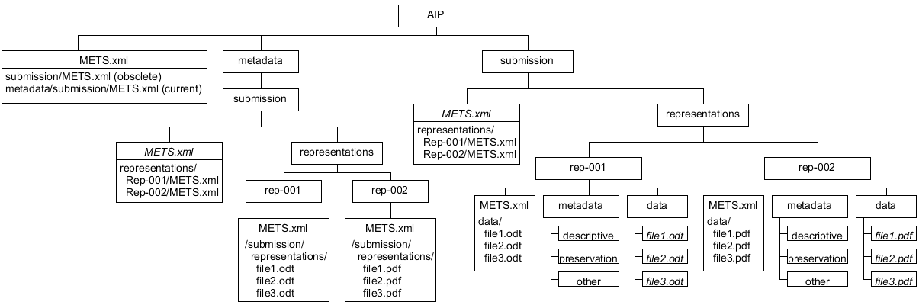

Figure 11: METS.xml files in the AIP’s “Metadata/submission” directory have priority over the ones contained in the original submission

1. Let <MDPath> be a sub-directory-path to a metadata file, then a metadata file under the “AIP/metadata/submission” directory MUST have priority over a metadata file under the “AIP/submission” directory so that **AIP/metadata/submission/<MDPath>** has priority over **AIP/submission/<MDPath>**.

An example is shown in Figure 11 where the *METS.xml* file in the root of the AIP references an obsolete *METS.xml* file of the original submission and a current *METS.xml* file under “metadata/submission”, i.e. the metadata file AIP/metadata/submission/METS.xml has priority over the metadata file AIP/submission/METS.xml. In this way users have the possibility to consult both the initial metadata and the updated metadata.

### Parent-Child relationship

As already pointed out, the divided METS structure was introduced to make the separation of representations or representation parts easier and allow the distribution of these components over a sequence of AIPs.

E-ARK allows the composition of a logical AIP to be expressed by a parent-child relationship between AIPs. It is a bidirectional relationship where each child-AIP bears the information about the parent-AIP to which they belong and, vice versa, the parent-AIP references the child-AIPs.

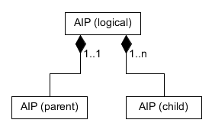

Figure 12: Parent-child relationship between AIPs

Even though this parent-child relationship could be used to create a hierarchical graph of AIPs, E-ARK only uses this method to aggregate representations or representation parts of the logical AIP.

Assuming that a new AIP (e.g. containing an additional representation) needs to be added after parent- and child-AIPs have been stored, the recreation of the whole logical AIP might be inefficient, especially if the AIPs are very large. For this reason, existing child-AIPs remain unchanged in case a new version of the parent-AIP is created. Only the new version of the parent-AIP has references to all child-AIPs as illustrated in Figure 13. As a consequence, in order to find all siblings of a single child-AIP it is necessary to get the latest version of the parent-AIP which implies the risk that the integrity of the logical AIP is in danger if the latest version of the parent-AIP is lost.

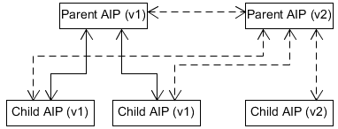

Figure 13: New version of a parent-AIP

The result of this process is a sequence of physical containers of child-AIPs plus one additional parent-AIP. The relation of the AIPs is expressed by means of structural metadata in the METS.xml files as described in the sections 5.3.1.6 and 5.3.1.7.

### Representation Information in the E-ARK AIP

Representation Information (RI) is a key concept in digital preservation and is defined by OAIS as follows:

“Representation Information: The information that maps a Data Object into more meaningful concepts. An example is the ASCII definition that describes how a sequence of bits (i.e., a Data Object) is mapped into a symbol.”

The RI is required to preserve data in a way that makes it possible to get meaningful information which a person or system is able to understand.

#### Types of Representation Information

Representation Information can be subdivided into three classes:

* **Structural Information**: describes the format and data structure concepts to be applied to the bitstream, which result in more meaningful values like characters or number of pixels.
* **Semantic Information**: this is needed on top of the structure information. If the digital object is interpreted by the structure information as a sequence of text characters, the semantic information should include details of which language is being expressed.
* **Other Representation Information**: includes information about relevant software, hardware and storage media, encryption or compression algorithms, and printed documentation.

The RI does not necessarily have to be documentation. It can also be executable software, such as a PDF viewer, or be expressed as metadata.

#### Representation networks

The RI may contain references to other RI components. And as the RI is in itself an Information Object, with its own Data Object and related Representation Information, a whole network of RI may be built up, which is called a **Representation network.**

#### Limitations of the Representation Information of the E-ARK AIP

The following figure, taken from the OAIS document, depicts which components are considered relevant in the context of an AIP definition. Aligning the following definition with the components currently present on the E-ARK AIP we can easily detect that Representation Information is actually missing from the specification.

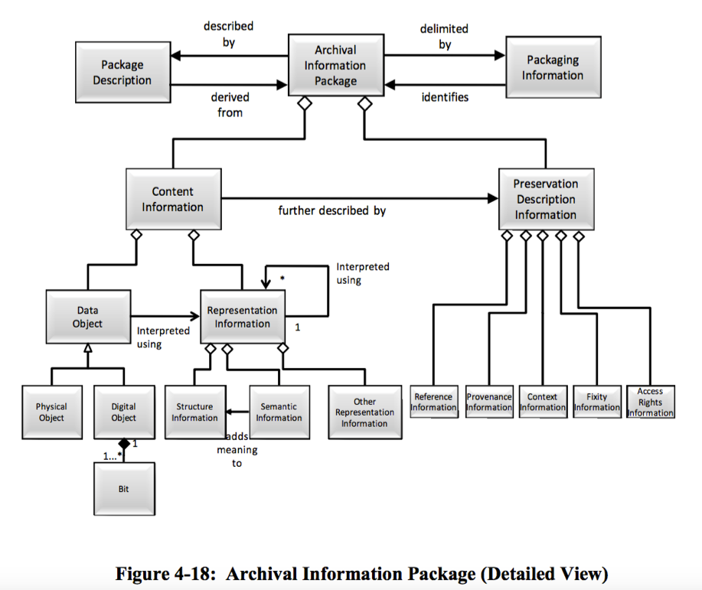

The AIP Common Specification foresees the “documentation” folder will hold specific information (other than metadata) about the content of the IP. This folder fulfils the requirements of the transfer of archival material from the producer to the archive.

However, in order to allow RI to be reusable, it is required that a specific RI actually be used for thousands of objects in a repository. For example, the description of what a PDF file is and how we can interpret it can be defined once, and thousands of PDF files in the repository can link to this single description. This RI could be either references to the actual PDF specification, links to external PDF viewers, the actual binaries of those viewers or even source-code in various programming languages.

Moreover, the RI may itself contain data, e.g. the visualization software, that needs to be updated over time. Having this unit of information stored physically inside the AIP means redundantly storing the same information many times.

#### Representation Information in the E-ARK AIP

The proposed approach to include representation information in the E-ARK AIP is to use a relationship model that enables the creation of links between an AIP and one or more “Representation Information packages”. These “Representation Information packages” follow the same structure of the current E-ARK AIP, meaning that they are composed of a metadata folder, representation folders, and all the other components that currently constitute the E-ARK AIP. It is recommended that this particular type of AIP follows a different naming scheme so that it is easy to distinguish this package type with the regular AIPs.

In this way it is possible to build an entire Representation Information network that follows the E-ARK AIP specification.

The relationship between these RI AIPs and regular AIPs is defined in the same way as the parent-child relationship between AIPs which is explained in section 5.2.4. It is recommended to implement this as a specific structMap as part of the METS structural metadata to define the relationships with RI AIPs. This structMap has the LABEL attribute “Representation Information”.

## E-ARK AIP metadata

The AIP format specifies the use of structural and preservation metadata. Any type of additional metadata, such as descriptive metadata using Dublin Core or EAD, can be used.

In the following, XML elements are either enclosed between angle brackets (e.g. <fileSpec>) or addressed using XPath syntax (e.g. /mets/metsHdr). In the latter case a leading slash selects a node from the XML document root and the double slash (’//’) selects nodes in the document from the current node that match the selection, no matter where they are. Also in line with the XPath syntax, element attributes have a leading ’@’ character. For example //mets:file/@USE denotes the ’USE’ attribute of a <file> element.

### Structural metadata

Structural metadata is expressed by means of the METS standard. Some of the high level functions which the standard fulfils in the context of the AIP are the following.

* It provides an overview about the hierarchical structure of the AIP.
* It is an entry point for the AIP, i.e. the first entity to consult to know what an AIP contains and what entities it references.
* It references or embeds any metadata files describing the package as a whole as well as individual content files.
* It contains a complete list of digital objects contained in a package together with basic information to ensure the integrity of the digital objects.
* It establishes links between digital objects and metadata entities (both structural metadata and preservation metadata entities).
* It can hold information about different representations or representation parts belonging to the same intellectual entity.

This section has a focus on METS, therefore, if no namespace prefix is given, the element belongs to the METS default namespace[26].

#### METS root element

##### METS identifier

Each METS document must be assigned a persistent and (ideally globally) unique identifier. Possible identifier schemes are amongst others: OCLC Purls[27], CNRI Handles[28], DOI[29]. Alternatively, it is possible to use a UUID as a locally unique identifier[30]. Using this identifier, the system must be able to retrieve the corresponding package from the repository.

In the in the context of the implementation as part of the E-ARK Integrated Platform, a UUID is used as identifier of an intellectual entity. The prefix “urn:uuid:” is used to state that the identifier can be used to locate physical packages as well. For example, if the package identifier value is "123e4567-e89b-12d3-a456-426655440000" this would be the value of the METS root element’s ‘OBJID’ attribute:

/mets/@OBJID="urn:uuid:123e4567-e89b-12d3-a456-426655440000"

##### Namespace and namespace schema definitions

1. The METS document MUST use at least the namespace and namespace schema definitions defined in table 1.

Table 1: Attributes of the METS root element

|  |  |  |
| --- | --- | --- |
| Attribute | Description | Value |
| //mets/@xmlns | METS-Namespace | http://www.loc.gov/METS/ |
| //mets/@xmlns:xlink | Xlink-Namespace | http://www.w3.org/1999/xlink |
| //mets/@xmlns:xsi | Schema-Instance | http://www.w3.org/2001/XMLSchema-instance |
| //mets/@xsi:schemaLocation | Schema-Location | http://www.loc.gov/METS/ http://www.loc.gov/standards/mets/mets.xsd http://www.w3.org/1999/xlink schemas/xlink.xsd |

An example of a root element with namespace and namespace location definitions is shown in Listing 1.

<mets

xmlns:mets="http://www.loc.gov/METS/"

xmlns:xlink="http://www.w3.org/1999/xlink"

xmlns:xsi="http://www.w3.org/2001/XMLSchema-instance"

xsi:schemaLocation="http://www.loc.gov/METS/ http://www.loc.gov/standards/mets/mets.xsd

http://www.w3.org/1999/xlink schemas/xlink.xsd">...</mets>

Listing 1: METS root element example with namespace and namespace location definitions

#### Digital objects

Digital objects are described in a file section (<fileSec>) of the METS document. Listing 2 shows an example of a file section with one file.

<fileSec>  
 <fileGroup @USE="Common Specification root">

<file ID="ID77146c6c-c8c3-4406-80b5-b3b41901f9d0"

ADMID="..." MIMETYPE="text/x-sql" SIZE="2862064"

CHECKSUMTYPE="SHA-256" CHECKSUM="..."

CREATED="2015-0501T01:00:00+01:00">

<FLocat LOCTYPE="URL"

xlink:href="./submission/data/content/file.ext"

xlink:type="simple"/>

</file>  
 <fileGroup>

</fileSec>

Listing 2: Example of a file in the fileSec as child of a fileGroup element (long attribute values replaced by “...” for better readability)

Table 2 lists the attributes of the <file> element with an example value. The /file/FLocat element provides the link to the actual file.

Table 2: Attributes of the file element

|  |  |  |
| --- | --- | --- |
| Attribute | Description | Value |
| //file/@ID | Identifier of a file wich is part of the AIP; must be unique and start with the prefix “ID” | ID77146c6c-c8c3-4406-80b5-b3b41901f9d0 |
| //file/@ADMID | Used to link it to relevant administrative metadata sections that relate to the digital object described. Can be a white space separated list of identifiers. | ID4566af74-0f7b-11e5-a6c0-1697f925ec7b ID4566af74-0f7b-11e5-a6c0-1697f925ec7c |
| //file/@CHECKSUMTYPE | Hash-sum calculator algorithm | SHA-256 |
| //file/@CHECKSUM | Hash-sum | 977fb584d53cd64662dfba427f3  5190813dfc58979f51a2703f8621  b9e1bc274 |
| //file/@CREATED | Date when the file entry was created. | 2014-05-01T01:00:00+01:00 |
| //file/@SIZE | Size of the file | 2498 |
| //file/@MIMETYPE | Mime-type | application/pdf |

Table 2 lists the attributes of the file element with an example value. The /file/FLocat element provides the link to the actual file.

The following rules apply for the URL attribute of the *<*FLocat*>* element:

1. The local file paths COULD indicate the protocol part (“file://”), in this case the path must be a valid URI according to RFC3986.[31]
2. If the protocol part is omitted, the path MUST be interpreted as a reference relative to the METS document (e.g. “./file.txt” or “file.txt” referring to the file “file.txt” in the current folder).

Additionally, the following requirement applies for compressed files:

1. If a file is compressed, the transformFile element (//file/transformFile) SHOULD indicate how the packages have to be processed by means of the attributes ’TRANSFORMTYPE’, ’TRANSFORMALGORITHM’, and ’TRANSFORMORDER’.

<file ...>

<FLocat xlink:href="../compressed.tar.gz" xlink:type="simple" LOCTYPE="URL"/>

<transformFile TRANSFORMORDER="1"  
 TRANSFORMTYPE="decompression" TRANSFORMALGORITHM="gzip"/>

<transformFile TRANSFORMORDER="2"   
 TRANSFORMTYPE="decompression" TRANSFORMALGORITHM="tar"/>

</file>

Listing 3: Compressed file

#### Referenced Metadata

Generally, the use of embedded metadata by using the <mdWrap> element is allowed by E-ARK. However, using the <mdRef> element is recommended.

1. External metadata files such as EAD[32] or PREMIS files MUST be referenced by means of the <mdRef> element. Its "xlink:href" attribute value must be either a URL relative to the location of the METS root or an absolute URL.

##### Descriptive metadata

The descriptive metadata section (<dmdSec>) references descriptive metadata contained in the AIP. Multiple <dmdSec> elements are allowed so that descriptive metadata file can be referenced separately within the METS object.

Descriptive metadata is referenced by means of the <mdRef> element as part of the descriptive metadata element <dmdSec>. Listing 4 shows an example linking to an EAD XML metadata file.

<dmdSec ID="ID550e8400-e29b-41d4-a716-44665544000a">

<mdRef LOCTYPE="URL" MDTYPE="EAD" MIMETYPE="text/xml"

CREATED="2015-04-26T12:00:00+01:00" xlink:type="simple"

xlink:href="./metadata/EAD.xml"

CHECKSUMTYPE="SHA-256" CHECKSUM="..." SIZE="2321"/>

</dmdSec>

Listing 4: Linking to an EAD XML descriptive metadata file

##### Administrative Metadata

1. The AIP METS must have a single <amdSec> element which contains one or several <digiprovMD> elements. The <mdRef> child of at least one of these elements must be of type “PREMIS” (@MDTYPE=”PREMIS”) with the reference to a PREMIS file in the “Metadata” directory of the AIP root.

Listing 5 shows an example with a link to a *PREMIS.xml* file:

<amdSec ID="...">  
 <digiprovMD ID="..." @STATUS="CURRENT">   
 <mdRef CHECKSUM="..." CHECKSUMTYPE="SHA-256"   
 CREATED="..." LOCTYPE="URL" MDTYPE="PREMIS"   
 MIMETYPE="text/xml" SIZE="1109"   
 xlink:href=" metadata/preservation/premis.xml" xlink:type="simple"/>   
 </digiprovMD>   
</amdSec>

Listing 5: Linking to an EAD XML descriptive metadata file

1. The @STATUS attribute value of the <digiprovMD> element SHOULD be “SUPERSEDED” if the PREMIS file is obsolete and only included in the AIP to ensure traceability.
2. The @STATUS attribute value of the <digiprovMD> element COULD be “CURRENT” to make explicit that the PREMIS file is active.

#### Structural map

1. One <structMap> with the LABEL attribute value “Common Specification structural map” MUST be present in the METS.xml file.

Listing 6 shows a structural map with the LABEL attribute value “Common Specification structural map”.

<structMap ID="IDf413c073-5b03-4499-830e-8ef724613bef" TYPE="physical" LABEL=" Common specifcation structural map">

<div>

<div LABEL="submission">

...

</div>

<div LABEL="representations">

<div LABEL="representations/rep-001">

...

</div>

</div>

</div>

</structMap>

Listing 6: Obligatory Common Specification structural map

##### Structural map of a divided METS structure

1. When an AIP uses the divided METS structure, i.e. the different representations have their own METS.xml file, the mandatory <structMap> MUST organize those METS.xml files through <mptr> and <fptr> entries, for each representation. The <mptr> node MUST reference the /<representation>/METS.xml and point at the corresponding <file> entry in the <fileSec> using the <fptr> element.

<structMap TYPE="physical" LABEL="Common Specification structural map">

   <div LABEL="d7ef386d-275b-4a5d-9abf-48de9c390339">

     <div LABEL="representations/images_mig-1">

       <mptr xlink:href="./representations/images_mig-1/METS.xml" xlink:title="Mets file describing representation: images_mig-1 of AIP: urn:uuid:d7ef386d-275b-4a5d-9abf-48de9c390339." LOCTYPE="URL" ID="IDc063ebaf-e594-4996-9e2d-37bf91009155"/>

       <fptr FILEID="IDfb9c37e7-1c90-4849-a052-1875e67853d5"/>

     </div>

     <div LABEL="representations/docs_mig-1">

       <mptr xlink:href="./representations/docs_mig-1/METS.xml" xlink:title="Mets file describing representation: docs_mig-1 of AIP: urn:uuid:d7ef386d-275b-4a5d-9abf-48de9c390339." LOCTYPE="URL" ID="ID335f9e55-17b2-4cff-b62f-03fd6df4adbf"/>

       <fptr FILEID="ID3f2268cd-7da9-4ad8-909b-4f17730dacaf"/>

     </div>

   </div>

</structMap>

Listing 7: Structural map referencing METS.xml files of the different representations

#### Metadata representation of the AIP structure

#### Child AIP references parent AIP

The optional reference to a parent AIP is expressed by a structural map with the LABEL attribute value “Parent”. Listing 8 shows an example where a UUID is used as the package identifier and the xlink:href attribute has the UUID identifier value of the referenced parent AIP as value. This identifier implicitly references the *METS.xml* file of the corresponding package. If other locator types, such as URN, URL, PURL, HANDLE, or DOI are used, the LOCTYPE attribute can be set correspondingly.

<structMap TYPE="logical" LABEL="parent AIP">  
 <div LABEL="AIP parent identifier">  
 <mptr xlink:href="urn:uuid:3a487ce5-63cf-4000-9522-7288e208e2bc"   
 xlink:title="Referencing the parent AIP of this AIP   
 (URN:UUID:3218729b-c93c-4daa-ad3c-acb92ab59cee)."   
 LOCTYPE="OTHER" OTHERLOCTYPE="UUID"  
 ID="ID755d4d5f-5c5d-4751-9652-fcf839c7c6f2"/>  
 </div>  
</structMap>

Listing 8: Using a structMap to reference the parent AIP

#### Parent AIP references child AIPs

The parent AIP which is referenced by child AIPs must have a structural map listing all child AIPs. Listing 9 shows the structural map of a parent AIP listing four child AIPs.

<structMap TYPE="logical" LABEL="child AIPs">

<div LABEL="child AIPs">  
 <div LABEL="child AIP">  
 <mptr xlink:href="urn:uuid:cea73348-741d-4594-ab8f-0b9e652c1099"   
 xlink:title="Referencing a child AIP."   
 LOCTYPE="OTHER" OTHERLOCTYPE="UUID"  
 ID="IDd98e416f-55a7-4237-8d45-59c22d221669"/>  
 </div>  
 <div LABEL="child AIP">  
 <mptr xlink:href="urn:uuid:cea73348-741d-4594-ab8f-0b9e652c1099"   
 xlink:title="Referencing a child AIP."   
 LOCTYPE="OTHER" OTHERLOCTYPE="UUID"  
 ID="ID70f8ec28-23f1-4364-9163-b3e99165b6e6"/>  
 </div>  
 <div LABEL="child AIP">  
 <mptr xlink:href="urn:uuid:3218729b-c93c-4daa-ad3c-acb92ab59cee"   
 xlink:title="Referencing a child AIP."   
 LOCTYPE="OTHER" OTHERLOCTYPE="UUID"  
 ID="ID77373d7f-e241-481b-bf89-675335beb049"/>  
 </div>  
 <div LABEL="child AIP">  
 <mptr xlink:href="urn:uuid:cea73348-741d-4594-ab8f-0b9e652c1099"   
 xlink:title="Referencing a child AIP."   
 LOCTYPE="OTHER" OTHERLOCTYPE="UUID"   
 ID="ID3f0cc05c-f27d-499d-a6fd-63bdfed13cb0"/>  
 </div>

</div>  
</structMap>

Listing 9: Using a structMap to reference the parent AIP

### Preservation metadata

As already mentioned, PREMIS (version 3[33]) is used to describe technical metadata of digital objects, rights metadata to define the rights status in relation to specific agents or for specific objects, and to record events that are relevant regarding the digital provenance of digital objects.

In the following sections, the PREMIS format and the way that it relates to the METS elements is described in detail. NOTE: in the listings showing PREMIS code parts, the prefix "premis" is omitted (default namespace is the PREMIS namespace[34]) while the "mets" prefix is explicitly added if a relation to the METS file is explained.

#### Vocabulary

The definition of a vocabulary for PREMIS is an ongoing process, therefore E-ARK does not define an exhaustive list of vocabularies that are to be used exclusively.

The basis of the preservation vocabulary used in E-ARK is the preservation schemes provided by the Library of Congress (LoC).[35] Additionally, recent contributions by the PREMIS Implementers Group (which are still “work in progress”) are taken into consideration.[36] And, finally, there are contributions made by E-ARK project partners based on experience and best practices.

The vocabularies listed in the following sections are therefore to be seen as core vocabularies which are able to be extended.

##### Identifier type

Values of *IdentifierType elements.

* local = Scope is the PREMIS file.
* uuid = UUID
* uri = Identifier that is a unique resource identifier.

##### Event type

The values of eventType elements are based on the LoC eventType preservation term.[37]

* adding emulation information - Adding emulation information.
* AIP validation - Validation of the AIP.
* archive - Archiving the AIP.
* capture - Obtaining a digital object.
* compression - compression of files.
* creation - Creating a new digital object.
* decompression - decompression of files.
* deaccession - The process of removing an object from the inventory of a repository.
* digital signature validation - The process of determining that a decrypted digital signature matches an expected value.
* decryption - Decryption of data.
* deletion - Removing a digital object from the repository.
* digital signature validation - Validating a digital signature.
* fixity check - Checking file hash sums.
* format identification - File format identification (e.g. PRONOM PUID).
* format validation - File format validation (e.g. using JHove).
* identifier assignment - Assignment of an identifier.
* ingestion - Adding digital objects to the repository.
* message digest calculation - Calculate the message digest of digital objects.
* migration - File format migration.
* replication - Creating an exact copy of a digital object.
* SIP creation - Creation of the SIP.
* SIP validation - Validation of the SIP.
* storage migration - Moving digital object to another storage medium.
* validation - Structure and compliance validation of the AIP.
* virus check - Virus check

##### Event outcome

Values of eventOutcome elements.

* success - Process was applied successfully
* failure - An error occurred

##### Agent Type

Values of agentType elements.

* software - Software agent
* person - Person agent
* organisation - Organisation agent
* hardware - Hardware agent

##### Rights granted - act

Generally, rights metadata in PREMIS are used to express restrictions which need to be taken into consideration from a technical perspective. It can express, for example if a software component is allowed to index the files contained in an archival package. Or it can express that a file may only be displayed in a specific rendering environment (e.g. one where printing is not allowed). It is therefore about allowing or disallowing specific actions from a technical perspective. It does not have to provide details about why certain actions are possible or not; those details are supposed to be described within descriptive metadata, but there are no requirements on how this has to be done.

Values of rightsGranted/act elements:

* discover
* display
* copy
* migrate
* publish
* modify
* delete
* print

##### Rights granted - restriction

Values of rightsGranted/restriction elements:

* GENERAL – the Rights statement must not be explicitly stated for each file object, action is allowed to be performed on each digital object. In this case it is sufficient to know that an agent has a specific right.
* PER_FILE – the Rights statement must be explicitly stated for each digital object. It is not sufficient to know if an agent has a specific right, it must be verified for each individual object if the specific right is given.

##### Relationship

Values of relationshipSubType elements. Logical relations to other AIPs.

* part of
* has part
* is sibling
* is version of

#### PREMIS object

The PREMIS object contains technical information about a digital object.

##### Object identifier

**Requirement 29**: If an identifier of type “local” MUST be used, this identifier SHOULD be valid in the scope of the PREMIS document.

**Requirement 30**: Other object identifiers of the allowed types COULD be used additionally to the identifier of type “local”.

The example shown in Listing 10 has one identifier which is valid in the scope of the PREMIS file of type “local”.

<objectIdentifier>

<objectIdentifierType>local</objectIdentifierType>

<objectIdentifierValue>fileId001</objectIdentifierValue>

</objectIdentifier>

Listing 10: Object identifier

##### Fixity

Fixity information is provided as a descendant of the objectCharacteristics element information in form of a SHA-256 hashsum, a fixed size 256-bit value. An example is shown in Listing 11.

<fixity>

<messageDigestAlgorithm>SHA-256</messageDigestAlgorithm>

<messageDigest>3b1d00f7871d9102001c77f...</messageDigest>

<messageDigestOriginator>/usr/bin/sha256sum</messageDigestOriginator>

</fixity>

Listing 11: Hashsum (value shortened)

##### File format

The format element MUST be provided either using the formatRegistry or the formatDesignation element subelements, or both. Regarding the formatRegistry, the Persistent Unique Identifier (PUID)[38] based on the PRONOM technical registry[39] can be used. An example is shown in Figure shown in Listing 12.

<format>  
 <formatDesignation>   
 <formatName>XML</formatName>   
 <formatVersion>1.0</formatVersion>   
 </formatDesignation>  
 <formatRegistry>

<formatRegistryName>PRONOM</formatRegistryName>

<formatRegistryKey>fmt/101</formatRegistryKey>

<formatRegistryRole>specification</formatRegistryRole>

</formatRegistry>

</format>

Listing 12: Optionally, the format version can be provided using the formatDesignation element.

##### Object characterisation

The JHOVE [40] technical characterisation result (XML format) is embedded as a descendant of the objectCharacteristicsExtension element. An example is shown in Listing 13.

<objectCharacteristicsExtension>

<jhove>

...

</jhove>

</objectCharacteristicsExtension>

Listing 13: JHove digital object characterisation

##### Original name

The original name is an optional element to hold the original file, an example is shown in Listing 14.

<originalName>originalfilename.ext</originalName>

Listing 14: Original name

##### Storage

The storage element COULD hold information about the physical location of the digital object. Ideally this is a resolvable URI, but it can also generally hold information needed to retrieve the digital object from the storage system (e.g. access control or for segmented AIPs). An example is shown in Listing 15.

<storage>

<contentLocation>

<contentLocationType>URI</contentLocationType>  
 <contentLocationValue>

/path/to/file.txt  
 </contentLocationValue>

</contentLocation>

<storageMedium>hard disk HD2253</storageMedium>

</storage>

Listing 15: Storage description

##### Relationship

This element contains the "part-of" relationship of the digital object. For digital objects included in the AIP, the value "is included in" of the relationshipSubType element means that a digital object is part of an AIP which is just making an explicit statement about a fact. More importantly, in the case of "segmented AIPs", it is used to express that an AIP is part of a parent AIP which is not expressed otherwise. An example of the latter case is shown in Listing 16.

<relationship>

<relationshipType>structural</relationshipType>

<relationshipSubType>is included in</relationshipSubType>

<relatedObjectIdentification>

<relatedObjectIdentifierType>repository</relatedObjectIdentifierType>

<relatedObjectIdentifierValue>

ID123e4567-e89b-12d3-a456-426655440000

</relatedObjectIdentifierValue>

</relatedObjectIdentification>

</relationship>

Listing 16: Relationship

##### Linking rights statement

If a linkingRightsStatementIdentifier child element object exists, there is a rights statement attached to the object. For example, only files which have the "discovery right" are being indexed in order to allow these files to be retrievable by the full-text search. An example of the latter case is shown in Listing 17.

<linkingRightsStatementIdentifier>  
 <linkingRightsStatementIdentifierType>  
 filepath  
 </linkingRightsStatementIdentifierType>

<linkingRightsStatementIdentifierValue>

metadata/file.xml

</linkingRightsStatementIdentifierValue>

</linkingRightsStatementIdentifier>

Listing 17: Rights statement

#### PREMIS event

##### Event identifier

The event identifier is an identifier that is valid in the scope of the PREMIS file. An example is shown in Listing 18.

<eventIdentifier>

<eventIdentifierType>local</eventIdentifierType>

<eventIdentifierValue>PDF to PDF/A</eventIdentifierValue>

</eventIdentifier>

Listing 18: Event identifier

##### Event date/time

Combined date and time in UTC format (ISO 8601), example shown in Listing 19.

<eventDateTime>2014-05-01T01:00:00+01:00</eventDateTime>

Listing 19: Event date/time

##### Link to agent/object

The event is linked to an agent and an object. In the example shown in listing 20 the SIP to AIP conversion software is linked as agent with identifier value ’Sip2Aip’ and the corresponding object is linked by the local UUID value. An example is shown in Listing 20.

<linkingAgentIdentifier>

<linkingAgentIdentifierType>local</linkingAgentIdentifierType>

<linkingAgentIdentifierValue>

earkweb-sip2aip

</linkingAgentIdentifierValue>

</linkingAgentIdentifier>

<linkingObjectIdentifier>

<linkingObjectIdentifierType>local</linkingObjectIdentifierType>

<linkingObjectIdentifierValue>

metadata/file.xml

</linkingObjectIdentifierValue>

</linkingObjectIdentifier>

Listing 20: Link to agent/object

##### Migration event type

The migration event (value of element eventIdentifierType is "migration") needs to be related to the event that created the source object by means of the relatedEventIdentification. An example is shown in Listing 21.

<event>

<eventIdentifier>

<eventIdentifierType>local</eventIdentifierType>

<eventIdentifierValue>migration-001</eventIdentifierValue>

</eventIdentifier>

<eventType>MIGRATION</eventType>

<eventDateTime>2015-09-01T01:00:00+01:00</eventDateTime>

<eventOutcomeInformation>

<eventOutcome>success</eventOutcome>

</eventOutcomeInformation>

<linkingAgentIdentifier>

<linkingAgentIdentifierType>local</linkingAgentIdentifierType>

<linkingAgentIdentifierValue>

FileFormatConversion001

</linkingAgentIdentifierValue>

</linkingAgentIdentifier>

<linkingObjectIdentifier>

<linkingObjectIdentifierType>local</linkingObjectIdentifierType>  
 <linkingObjectIdentifierValue>

metadata/file.xml

</linkingObjectIdentifierValue>

</linkingObjectIdentifier>

<relatedEventIdentification>

<relatedEventIdentifierType>local</relatedEventIdentifierType>

<relatedEventIdentifierValue>

ingest-001

</relatedEventIdentifierValue>

</relatedEventIdentification>

</event>

Listing 21: Migration event

The event shown in Listing 21 expresses the fact that the object "metadata/file.xml" is the result of the migration event "migration-001"and the event which created the source object is "ingest-001".

#### PREMIS agent

The agent element holds information about agents (people, organizations or software). As an example for an agent, the listing shows the Lily[41] software which in the E-ARK project is used to index the text content of archival information packages. There is the "discovery right" assigned to this agent. The example is shown in Listing 22.

<agent>

<agentIdentifier>

<agentIdentifierType>local</agentIdentifierType>

<agentIdentifierValue>Lily</agentIdentifierValue>

</agentIdentifier>

<agentName>E-ARK Lily</agentName>

<agentType>Software</agentType>

<linkingRightsStatementIdentifier>

<linkingRightsStatementIdentifierType>

local

</linkingRightsStatementIdentifierType>

<linkingRightsStatementIdentifierValue>

discovery-right-001

</linkingRightsStatementIdentifierValue>

</linkingRightsStatementIdentifier>

</agent>

Listing 22: Software as an agent

#### PREMIS rights

The “rights” element holds information about the rights status of individual digital objects or about agents.

As an example for an agent, the listing shows the software Lily which in the E-ARK project is used to index the text content of archival information packages. There is the "discovery right" assigned to this agent. An example is shown in Listing 23.

<rights>

<rightsStatement>

<rightsStatementIdentifier>

<rightsStatementIdentifierType>

local

</rightsStatementIdentifierType>

<rightsStatementIdentifierValue>

discovery-right-001

</rightsStatementIdentifierValue>

</rightsStatementIdentifier>

<rightsBasis>Statute</rightsBasis>

<rightsGranted>

<act>Discovery</act>

<restriction></restriction>

</rightsGranted>

</rightsStatement>

</rights>

Listing 23: Discovery right statement

## E-ARK AIP Physical Container Package

Part of the E-ARK AIP format is the specification which shows how the AIP is packaged into a transferable and storable entity.

As a convention, regarding the *earkweb* reference implementation, there is the assumption of a one-to-one relationship between an SIP and the corresponding AIP as described in section 4.6. As a consequence, merging or splitting of AIPs is not supposed to happen during SIP to AIP conversion. For archived AIPs it means that the operation of changing the partition of a logical AIP is done by retrieving the corresponding packages and creating the desired division of SIPs which is then converted one-by-one into the resultant AIP(s).

In the E-ARK project, SIPs must be of a manageable size. There is no fixed size which defines what "manageable" means, because this depends on limitations given by the hardware, software, and network environment and especially on the storage media which is used for long-term preservation.

### Package manifest

Provided as a convenience for developers, in addition to fixity information included in the METS file, the E-ARK AIP COULD contain a manifest file (manifest.txt) with a complete list of files with MD5 and SHA-256 hashsum.

The manifest is a text file containing a list of records separated by two line breaks (two carriage return characters (hexadecimal 0D0D) or two times carriage return/line feed (hexadecimal 0D0A0D0A). A record is a list of named fields, the minimum fields being:

* Name := File path relative to the AIP root
* Size := Size in bytes
* SHA256 := SHA-256 Checksum
* MD5 := MD5 Checksum

An example is shown in Listing 24.

Name: METS.xml  
Size: 12135  
SHA256: d7dec534d2ba5f455391e2ed0cb89db89a2780e0531c83def79b0b0abcb38679  
MD5: e94dd23e792bd7e49721a863ad8ed769

Name: metadata/PREMIS.xml  
Size: 53719  
SHA256: ef01bc59a21f6e99ad3d87b0d25b89d6e8b4915c63dadb8791d9490739fe26d4  
MD5: 96b85205a9b4b0b5d3c88e2e51b0dc4c

Listing 24: Manifest file

#### Naming the physical container of the AIP

When creating an AIP, a unique identifier is assigned, which defines the AIP as one coherent logical entity. This identifier should also used to derive the name of the physical storage container.[42]

This is to say that there should be a unique way of deriving the folder name from the identifier string in such a way that folder name is at least in compliance with Windows and Unix File Naming conventions.

More concretely, the recommendation is to encode special characters according to the pairtree character mapping specification.[43]

For example, let us assume the identifier of the AIP was:

urn:uuid:123e4567-e89b-12d3-a456-426655440000

Then this identifier string would be converted to the folder name because “: -> +” is defined as a single-character to single-character conversion:

urn+uuid+123e4567-e89b-12d3-a456-426655440000

Also packaged entity should also bear this name, e.g. packaged as a gunzipped TAR the name would be:

urn+uuid+123e4567-e89b-12d3-a456-426655440000.tar.gz

# Appendices

## Appendix A - METS.xml referencing representation METS.xml files

<fileSec>

<fileGrp USE="Common Specification root" ID="ID0d4f09a8-0734-49fb-9bea-dbf6a3f5a444">

<file MIMETYPE="application/xml" USE="Datafile" CHECKSUMTYPE="SHA-256" CREATED="2016-12-14T09:15:24" CHECKSUM="8d3f057ac0e45ef173f9ecbfc432b994415c405259aff694632925faf108f541" ID="ID3af3e474-991a-4aad-b453-ed3f91d54280" SIZE="2855">

<FLocat xlink:href="./representations/images_mig-1/METS.xml" xlink:type="simple" LOCTYPE="URL"/>

</file>

<file MIMETYPE="application/xml" USE="Datafile" CHECKSUMTYPE="SHA-256" CREATED="2016-12-14T09:15:24" CHECKSUM="81e028df7468ea611b0714148cb607ec74fe1e7914bd762605f38631d21281e9" ID="IDe1df6f8b-8cc0-442d-bc45-e61724c63372" SIZE="2873">

<FLocat xlink:href="./representations/docs_mig-1/METS.xml" xlink:type="simple" LOCTYPE="URL"/>

</file>

</fileGrp>

</fileSec>

<structMap TYPE="physical" LABEL="Common Specification structural map">

<div LABEL="urn:uuid:7ff70669-73a0-4551-ad5b-12ed9b229e38">

<div LABEL="submission">

<!-- removed to improve readability -->

</div>

<div LABEL="metadata">

<!-- removed to improve readability -->

</div>

<div LABEL="schemas">

<!-- removed to improve readability -->

</div>

<div LABEL="representations"/>

<div LABEL="representations/images_mig-1">

<mptr xlink:href="./representations/images_mig-1/METS.xml" xlink:title="Mets file describing representation: images_mig-1 of AIP: urn:uuid:7ff70669-73a0-4551-ad5b-12ed9b229e38." LOCTYPE="URL" ID="ID0799bb22-b3b1-4661-b32d-5c2dae0341f9"/>

<fptr FILEID="ID3af3e474-991a-4aad-b453-ed3f91d54280"/>

</div>

<div LABEL="representations/docs_mig-1">

<mptr xlink:href="./representations/docs_mig-1/METS.xml" xlink:title="Mets file describing representation: docs_mig-1 of AIP: urn:uuid:7ff70669-73a0-4551-ad5b-12ed9b229e38." LOCTYPE="URL" ID="IDcc2c70c5-9712-4697-834c-5d5acad47f49"/>

<fptr FILEID="IDe1df6f8b-8cc0-442d-bc45-e61724c63372"/>

</div>

</div>

</structMap>

## Appendix B – METS.xml describing a representation

<mets xmlns:ext="ExtensionMETS" xmlns:xsi="http://www.w3.org/2001/XMLSchema-instance" xmlns:xlink="http://www.w3.org/1999/xlink" xmlns="http://www.loc.gov/METS/" PROFILE="http://www.ra.ee/METS/v01/IP.xml" TYPE="AIP" OBJID="urn:uuid:docs_mig-1" LABEL="METS file describing the AIP matching the OBJID." xsi:schemaLocation="http://www.loc.gov/METS/ ../../schemas/mets_1_11.xsd http://www.w3.org/1999/xlink ../../schemas/xlink.xsd">

<metsHdr RECORDSTATUS="NEW" CREATEDATE="2016-12-14T09:15:24">

<agent TYPE="OTHER" ROLE="CREATOR" OTHERTYPE="SOFTWARE">

<name>E-ARK earkweb</name>

<note>VERSION=0.0.1</note>

</agent>

<metsDocumentID>METS.xml</metsDocumentID>

</metsHdr>

<amdSec ID="IDfacb861c-5f25-43f7-a1a4-86dfa345a119">

<digiprovMD ID="IDc4113098-6eb5-43f5-9618-6f33ef442400">

<mdRef MIMETYPE="application/xml" xlink:href="./metadata/preservation/premis.xml" LOCTYPE="URL" CREATED="2016-12-14T09:15:24" CHECKSUM="d9e3bdc2c2e1d1a07cd88585dfddad62cdf40ca060e09456efc68bd2dc88e3a9" xlink:type="simple" ID="ID2c990270-d140-4d92-8bca-629e21926535" MDTYPE="PREMIS" CHECKSUMTYPE="SHA-256"/>

</digiprovMD>

</amdSec>

<fileSec>

<fileGrp USE="Common Specification representation urn:uuid:docs_mig-1" ID="IDcee0bbc3-ac88-4f21-834e-2c06104141ac">

<file MIMETYPE="application/pdf" USE="Datafile" CHECKSUMTYPE="SHA-256" CREATED="2016-12-14T09:15:05" CHECKSUM="d50fe727b6bed7b04569671a46d4d8a56b93c295afb69703b14c0544286ff86c" ID="IDcf9818bb-567b-44ee-88d8-60a1420feae3" SIZE="2530049">

<FLocat xlink:href="./data/Suleiman the Magnificent.pdf" xlink:type="simple" LOCTYPE="URL"/>

</file>

<file MIMETYPE="application/pdf" USE="Datafile" CHECKSUMTYPE="SHA-256" CREATED="2016-12-14T09:15:12" CHECKSUM="3824fb493235e94bcca3baf33c93a9e4f62d4af387ce055560f01c274ef63da9" ID="ID3b0e4dcb-727a-44d1-af24-d35676b02bed" SIZE="7603618">

<FLocat xlink:href="./data/Charlemagne.pdf" xlink:type="simple" LOCTYPE="URL"/>

</file>

</fileGrp>

</fileSec>

<structMap TYPE="physical" LABEL="Common Specification structural map">

<div LABEL="docs_mig-1">

<div LABEL="metadata">

<fptr FILEID="ID2c990270-d140-4d92-8bca-629e21926535"/>

</div>

<div LABEL="data">

<fptr FILEID="IDcf9818bb-567b-44ee-88d8-60a1420feae3"/>

<fptr FILEID="ID3b0e4dcb-727a-44d1-af24-d35676b02bed"/>

</div>

</div>

</structMap>

<structMap TYPE="logical" LABEL="Simple AIP structuring">

<div LABEL="Package structure">

<div LABEL="metadata files">

<fptr FILEID="ID2c990270-d140-4d92-8bca-629e21926535"/>

</div>

<div LABEL="schema files"/>

<div LABEL="content files">

<fptr FILEID="IDcf9818bb-567b-44ee-88d8-60a1420feae3"/>

<fptr FILEID="ID3b0e4dcb-727a-44d1-af24-d35676b02bed"/>

</div>

</div>

</structMap>

</mets>

## Appendix C - PREMIS.xml describing events on package level

<premis xmlns="info:lc/xmlns/premis-v2" xmlns:xsi="http://www.w3.org/2001/XMLSchema-instance" version="2.0" xsi:schemaLocation="info:lc/xmlns/premis-v2 ../../schemas/premis-v2-2.xsd">

<object xmlID="ID187f239d-c080-4a7f-936d-b35cec4e8ef7" xsi:type="representation">

<objectIdentifier>

<objectIdentifierType>repository</objectIdentifierType>

<objectIdentifierValue>urn:uuid:7ff70669-73a0-4551-ad5b-12ed9b229e38</objectIdentifierValue>

</objectIdentifier>

</object>

<event>

<eventIdentifier>

<eventIdentifierType>local</eventIdentifierType>

<eventIdentifierValue>IDc5d159d7-2df0-4efe-b07b-559fac4bdc27</eventIdentifierValue>

</eventIdentifier>

<eventType>SIP Delivery Validation</eventType>

<eventDateTime>2016-12-14T09:14:04</eventDateTime>

<eventOutcomeInformation>

<eventOutcome>success</eventOutcome>

</eventOutcomeInformation>

<linkingAgentIdentifier>

<linkingAgentIdentifierType>software</linkingAgentIdentifierType>

<linkingAgentIdentifierValue>E-ARK Web 0.9.4 (task: SIPDeliveryValidation)</linkingAgentIdentifierValue>

</linkingAgentIdentifier>

<linkingObjectIdentifier>

<linkingObjectIdentifierType>repository</linkingObjectIdentifierType>

<linkingObjectIdentifierValue>urn:uuid:7ff70669-73a0-4551-ad5b-12ed9b229e38</linkingObjectIdentifierValue>

</linkingObjectIdentifier>

</event>

<agent>

<agentIdentifier>

<agentIdentifierType>LOCAL</agentIdentifierType>

<agentIdentifierValue>E-ARK Web 0.9.4</agentIdentifierValue>

</agentIdentifier>

<agentName>E-ARK Web</agentName>

<agentType>Software</agentType>

</agent>

</premis>

## Appendix D - PREMIS.xml describing migration events (representation level)

<premis xmlns="info:lc/xmlns/premis-v2" xmlns:xsi="http://www.w3.org/2001/XMLSchema-instance" version="2.0" xsi:schemaLocation="info:lc/xmlns/premis-v2 ../../schemas/premis-v2-2.xsd">

<object xmlID="ID983381f2-edc7-4264-aaf8-10a33dc7a811" xsi:type="representation">

<objectIdentifier>

<objectIdentifierType>repository</objectIdentifierType>

<objectIdentifierValue>ID983381f2-edc7-4264-aaf8-10a33dc7a811</objectIdentifierValue>

</objectIdentifier>

</object>

<object xmlID="ID37b54f97-bef3-4018-abd0-dfd71216fa5f" xsi:type="file">

<objectIdentifier>

<objectIdentifierType>filepath</objectIdentifierType>

<objectIdentifierValue>./data/bluemarble.tiff</objectIdentifierValue>

</objectIdentifier>

<objectCharacteristics>

<compositionLevel>0</compositionLevel>

<fixity>

<messageDigestAlgorithm>SHA-256</messageDigestAlgorithm>

<messageDigest>773a144dac9ec7844939ce52619b7580d1c7642c7257947d86eaa5f1ffbcb7a0</messageDigest>

<messageDigestOriginator>hashlib</messageDigestOriginator>

</fixity>

<size>1746308</size>

<format>

<formatRegistry>

<formatRegistryName>PRONOM</formatRegistryName>

<formatRegistryKey>fmt/353</formatRegistryKey>

<formatRegistryRole>identification</formatRegistryRole>

</formatRegistry>

</format>

</objectCharacteristics>

<relationship>

<relationshipType>derivation</relationshipType>

<relationshipSubType>has source</relationshipSubType>

<relatedObjectIdentification>

<relatedObjectIdentifierType>local</relatedObjectIdentifierType>

<relatedObjectIdentifierValue>../../submission/representations/images/data/bluemarble.gif</relatedObjectIdentifierValue>

<relatedObjectSequence>0</relatedObjectSequence>

</relatedObjectIdentification>

<relatedEventIdentification>

<relatedEventIdentifierType>local</relatedEventIdentifierType>

<relatedEventIdentifierValue>ID27c87d0a-0abd-44e4-bfde-05fdaa34e620</relatedEventIdentifierValue>

<relatedEventSequence>1</relatedEventSequence>

</relatedEventIdentification>

</relationship>

</object>

<event>

<eventIdentifier>

<eventIdentifierType>local</eventIdentifierType>

<eventIdentifierValue>ID27c87d0a-0abd-44e4-bfde-05fdaa34e620</eventIdentifierValue>

</eventIdentifier>

<eventType>migration</eventType>

<eventDateTime>2016-12-14T09:15:01</eventDateTime>

<eventOutcomeInformation>

<eventOutcome>success</eventOutcome>

</eventOutcomeInformation>

<linkingAgentIdentifier>

<linkingAgentIdentifierType>software</linkingAgentIdentifierType>

<linkingAgentIdentifierValue>Version: ImageMagick 6.7.7-10 2016-06-01 Q16 http://www.imagemagick.orgCopyright: Copyright (C) 1999-2012 ImageMagick Studio LLCFeatures: OpenMP </linkingAgentIdentifierValue>

</linkingAgentIdentifier>

<linkingObjectIdentifier>

<linkingObjectIdentifierType>local</linkingObjectIdentifierType>

<linkingObjectIdentifierValue>./data/bluemarble.tiff</linkingObjectIdentifierValue>

</linkingObjectIdentifier>

</event>

<agent>

<agentIdentifier>

<agentIdentifierType>LOCAL</agentIdentifierType>

<agentIdentifierValue>E-ARK Web 0.9.4</agentIdentifierValue>

</agentIdentifier>

<agentName>E-ARK Web</agentName>

<agentType>Software</agentType>

</agent>

<agent>

<agentIdentifier>

<agentIdentifierType>LOCAL</agentIdentifierType>

<agentIdentifierValue>Version: ImageMagick 6.7.7-10 2016-06-01 Q16 http://www.imagemagick.orgCopyright: Copyright (C) 1999-2012 ImageMagick Studio LLCFeatures: OpenMP </agentIdentifierValue>

</agentIdentifier>

<agentName>Version: ImageMagick 6.7.7-10 2016-06-01 Q16 http://www.imagemagick.orgCopyright: Copyright (C) 1999-2012 ImageMagick Studio LLCFeatures: OpenMP </agentName>

<agentType>Software</agentType>

</agent>

</premis>

1. <http://www.eark-project.com/resources/project-deliverables/89-d44>
2. See E-ARK deliverable 6.2 “Integrated Platform Reference Implementation”, section 6, <http://www.eark-project.com/resources/project-deliverables/54-d62intplatformref-1>
3. <https://github.com/eark-project/earkweb>; the actual SIP to AIP conversion component consists of a set of tasks in <https://github.com/eark-project/earkweb/blob/master/workers/tasks.py>.
4. In the following short “Common Specification” which refers to E-ARK Draft Common Specification for the Information Packages in the E-ARK project, version 0.17, <http://eark-project.com/resources/specificationdocs/67-e-ark-draft-common-specification-ver-017/file>
5. <https://github.com/eark-project/earkweb>; the actual SIP to AIP conversion component consists of a set of tasks in <https://github.com/eark-project/earkweb/blob/master/workers/tasks.py>.
6. <http://www.eark-project.com/resources/project-deliverables/89-d44>
7. See E-ARK deliverable 6.2 “Integrated Platform Reference Implementation”, section 6, <http://www.eark-project.com/resources/project-deliverables/54-d62intplatformref-1>
8. <https://github.com/eark-project/earkweb>; the actual SIP to AIP conversion component consists of a set of tasks in <https://github.com/eark-project/earkweb/blob/master/workers/tasks.py>.
9. Reference Model for an Open Archival Information System (OAIS); Retrieved from <http://public.ccsds.org/publications/archive/650x0m2.pdf>, in the following we are always referring to this version 2 of the OAIS which was published in June 2012 by CCSDS as "magenta book" (ISO 14721:2012). The document is cited using the abbreviation OAIS.
10. D3.3 E-ARK SIP Pilot Specification (<http://eark-project.com/resources/project-deliverables/51-d33pilotspec>)
11. A “submission update” is a re-submission of an SIP at a later point in time related to an AIP which contains a previous version of this SIP. Section 5.2.1 explains this concept more in detail.
12. See also Common Specification, p. 24.
13. <https://github.com/eark-project/earkweb>; the actual SIP to AIP conversion component consists of a set of tasks in <https://github.com/eark-project/earkweb/blob/master/workers/tasks.py>.
14. Preservation Metadata: Implementation Strategies, http://www.loc.gov/standards/premis
15. Introduction and Supporting Materials from PREMIS Data Dictionary, <http://www.loc.gov/standards/premis/v2/premis-report-2-1.pd>f, p. 7.
16. Metadata Encoding and Transmission Standard, http://www.loc.gov/standards/mets/
17. OAIS, p. 4-52 (95).
18. OAIS, p. 1-9 (19).
19. OAIS, p. 5-10 (108).
20. Reference Model for an Open Archival Information System (OAIS); Retrieved from <http://public.ccsds.org/publications/archive/650x0m2.pdf>, p. 2-8 (34).
21. In the following, the abbreviation "IP" is used to refer to a common set of standards and structure definitions which are valid for all types of information packages, i.e. independently from the fact if it is a Submission Information Package (SIP), Archival Information Package (AIP), or Dissemination Information Package (DIP).
22. The requirements terminology is based upon RFC2119, "Key words for use in RFCs to indicate requirement levels", RFC 2119, S. Bradner, March 1997. Available at: http://www.ietf.org/rfc/rfc2119.txt
23. The variable name in curly brackets means that the name of this directory can be chosen freely.
24. For the sake of simplicity, the examples show only references to data files and not to metadata files.
25. http://pdf.editme.com/PDFA
26. http://www.loc.gov/METS/
27. http://purl.org/docs/index.html
28. http://www.handle.net/
29. http://www.do i.org
30. Universally Unique Identifier according to RFC 4122, http://tools.ietf.org/html/rfc4122.html
31. https://tools.ietf.org/html/rfc3986
32. Encoded Archival Description, http://www.loc.gov/ead/
33. http://www.loc.gov/standards/premis/v3/premis-3-0-final.pdf
34. Namespace: info:lc/xmlns/premis-v2, namespace schema location: http://www.loc.gov/standards/premis/v2/premis-v2-2.xsd
35. http://id.loc.gov/vocabulary/preservation.html
36. http://premisimplementers.pbworks.com/w/page/  
    102413902/Preservation%20Events%20Controlled%20Vocabulary
37. http://id.loc.gov/vocabulary/preservation/eventType.html
38. http://www.nationalarchives.gov.uk/aboutapps/pronom/puid.htm
39. http://www.nationalarchives.gov.uk/PRONOM
40. http://sourceforge.net/projects/jhove/
41. http://www.ngdata.com/press-piece/lily-1-0-smart-data-at-scale-made-easy/
42. See D 4.4, part B.
43. <https://tools.ietf.org/html/draft-kunze-pairtree-01> (see section 3: “Identifier string cleaning”)